SPECIFICATION
Part Number: L.SLQ005
Part Description: Artwork, Label, Suspension

Purpose

This document provides the artwork specification for the Silq Suspension (L.SLQ005).

Supplier

Silq Technologies Corp., 311 Otterson Dr., Suite 60, Chico, CA 95928

Specification

Label Material Specification

Part number: C.SLQ002

Part description: Label Stock, 4” x 6”, White

Artwork Specification

See Section 4 Label Artwork. DYMO template can be found in Attachment 1.

Printer Specification

Printer: DYMO LabelWriter 5XL (Dymo Item #: 2112554)

Label Artwork

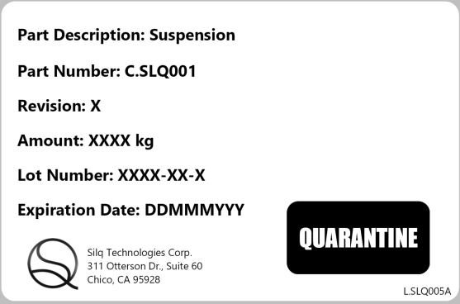

Attachments

Label, C.SLQ001 Suspension.dymo

